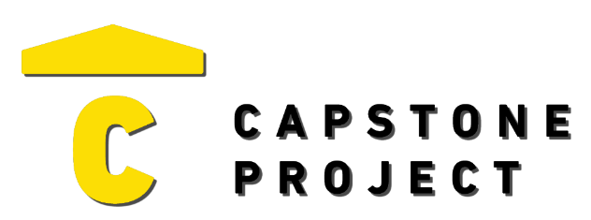
USER FEEDBACK
User Name: Julian Bernal
What are your thoughts on the project overall?
This was actually really cool. The app felt like something you could actually download on the app store. The security theme was a good idea

Was the project enjoyable? What was your favorite part of the project?
Yeah, it was fun to go through. I liked being able to add devices and seeing the alerts pop up when you trigger them.
What changes would improve the project?
Maybe add some kind of sound when you arm it or get an alert.

Capstone Project Ratings:
Project Technology Depth (shows good usage of technology) | High
Project Breadth (number of features and content) | High
Professional Presentation (analogous to a real-world product) | High
Implementation Quality (number of bugs and errors) | High
Project Completeness (project contains essential functionality) | High

Game / Application / Website Ratings:
Visuals (art style, environment, effects) | Very Positive
Audio (sound effects, music) | Mixed
UI (title, menus, UI elements, text) | Very Positive
Controls (intuitive, ease of use, ease of navigation) | Very Positive
Interactivity (fun, engagement, flow) | Positive

